Contents

Install certificate on IIS 1

Receive server certificates 1

Install CA certificate from windows explorer 1

Complete certificate request from inetmgr 1

Change binding 1

Test 1

# Install certificate on IIS

## Receive server certificates

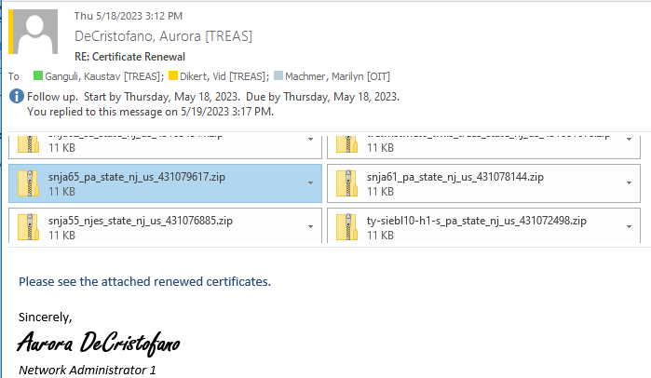

## Install CA certificate from windows explorer

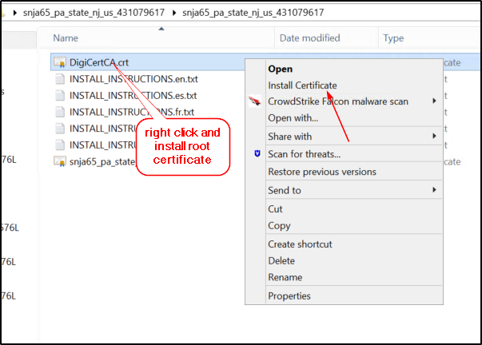

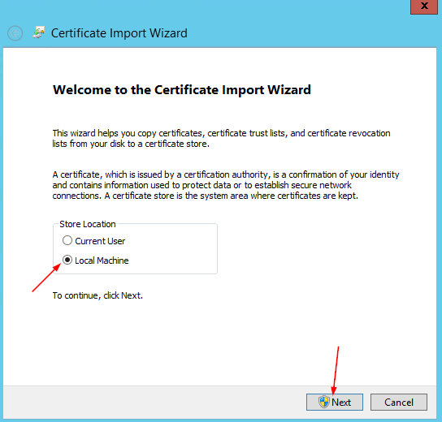

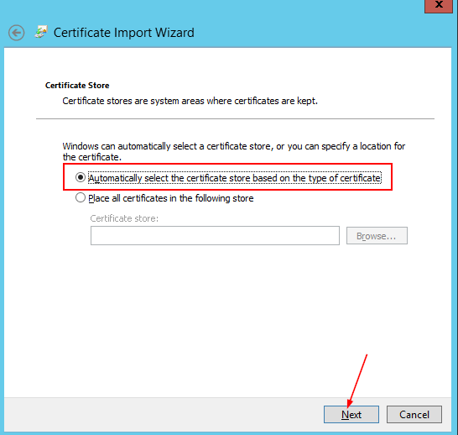

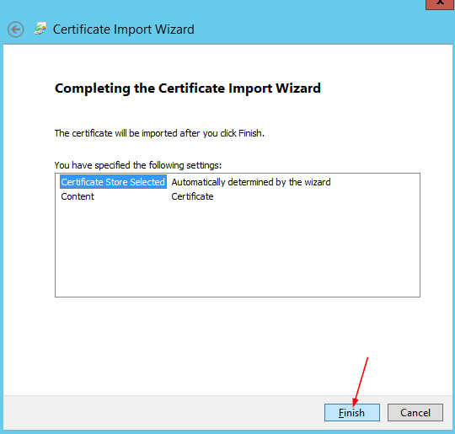

**IT WILL TAKE A LONG TIME TO IMPORT..WAIT**

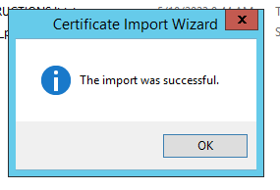

## Complete certificate request from inetmgr

Open inetmgr as administrator (running as administrator is not mandatory but it rules out any access issue)

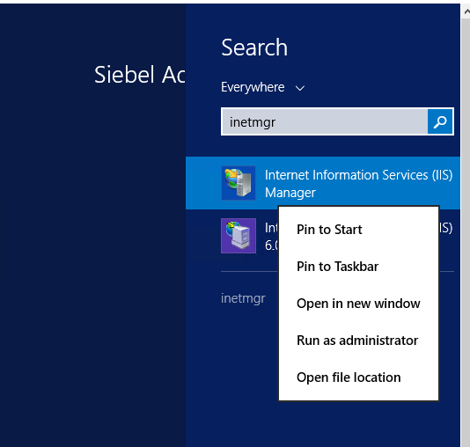

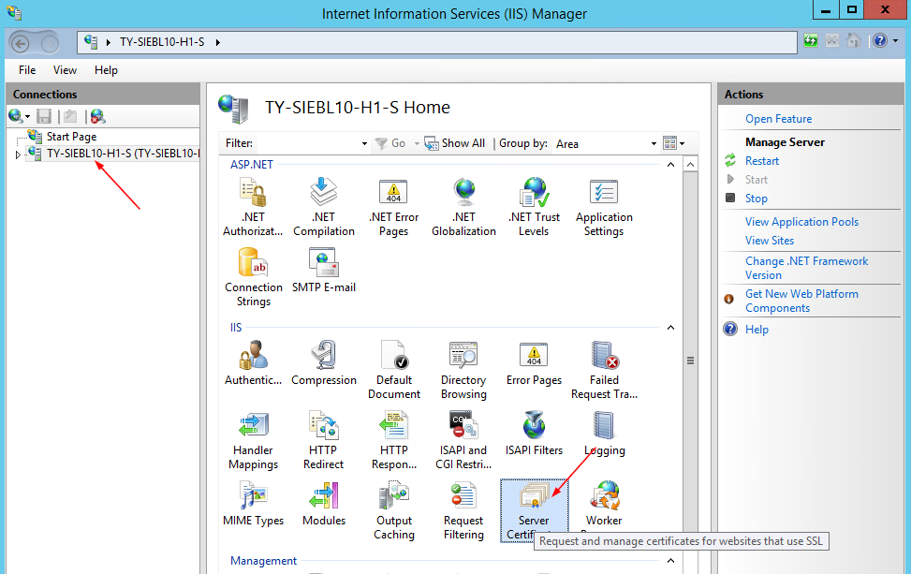

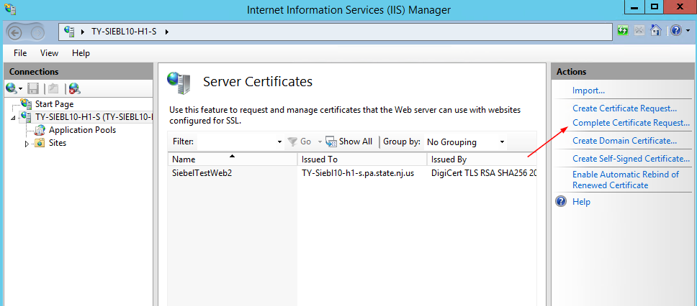

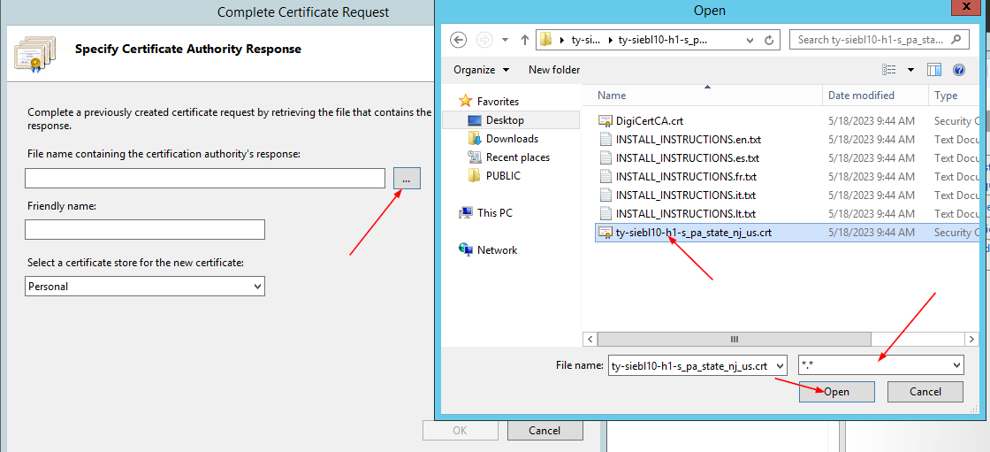

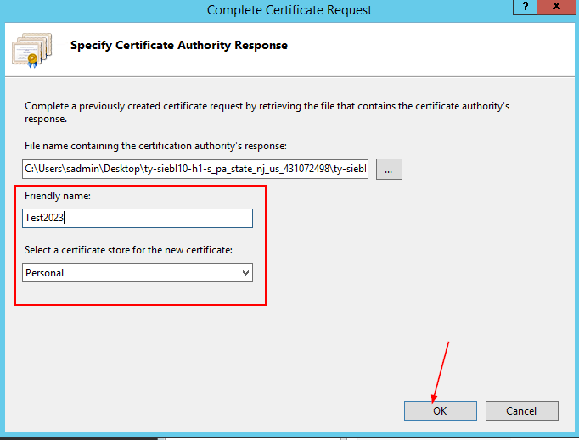

It will also take some time ..wait

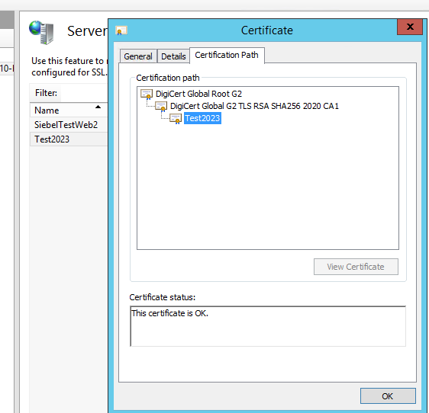

## Change binding

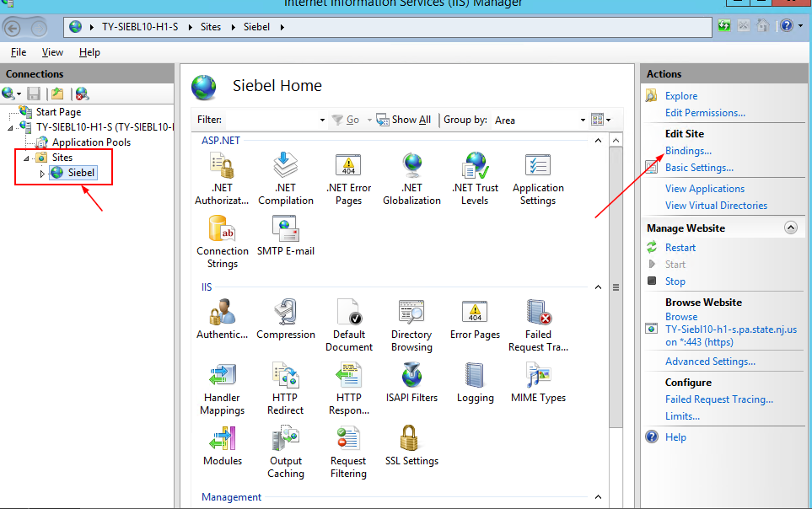

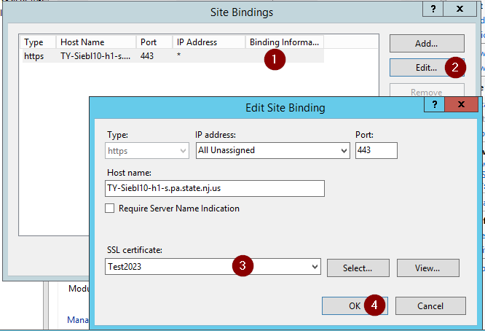

## Test

No need to restart iis

